Name: ______________________________________________________ Entry #: _____

**The Water Planet**

*The Earth as seen from space looks like a blue-colored planet with constant moving swirls of clouds. The earth is mostly blue because of its large surface area of oceans. The surface area of the waters of the planet takes up roughly 70% of earths total surface area while the land takes up about 30%.*

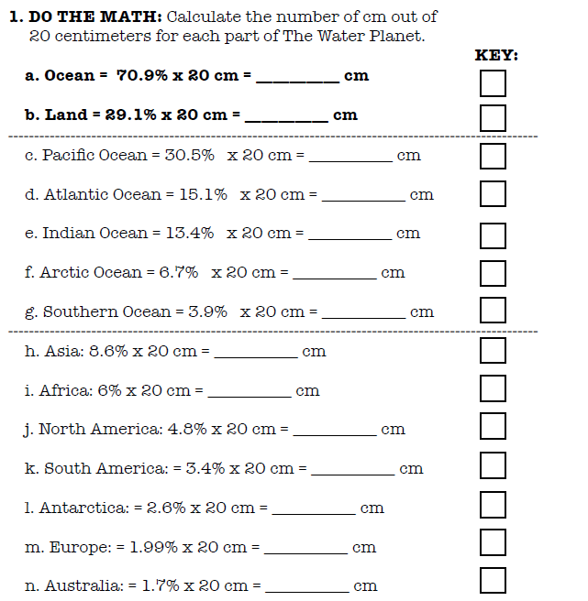

1. **Color in the Ocean and Land:** Color only the left half of the 20 cm strip to represent the percentage of ocean and land (a. and b.). The right half will be for the oceans and continents (c. through n.).
2. **Color in the Oceans and Continent:** Color only the right half of the 20 cm strip to represent the percentage for each ocean and continent(c. through n.).

Summary Questions:

1. How much of the Earth’s total surface area is the land?
2. How much of the Earth’s total surface area is the water?
3. List the five oceans in order of size from largest to smallest.

Ocean Percentage

* 1. _______________ ________
  2. _______________ ________
  3. _______________ ________
  4. _______________ ________
  5. _______________ ________

1. If you did the coloring correctly, you should have a small slice on the right hand side that was supposed to be water, but is NOT labeled as one of the five oceans. What do you think that area should be labeled? ____________________________________________________

What is the percentage? ____________________

1. How much of the Earth’s water is Salt Water, contained in the oceans and seas on the planet?
2. How much of the Earth’s water is Fresh Water, found on the land of the planet?
3. How much of the Earth’s Fresh Water is actually readily accessible for humans to use?
4. Explain why the Earth is called the Water Planet?